## Úloha 1

* Vygenerovali sme prevádzku HTTP, HTTPS, FTP, SFTP
* Na sériovom rozhraní odosielateľa sme zapli

auto discovery qos

auto qos

Na smerovači sa automaticky vytvorila *policy-map*

*Oct 10 07:31:07.511: %SYS-3-CPUHOG: Task is running for (2008)msecs, more than (2000)msecs (3/2),process = Exec.

-Traceback= 0x45FF11F4z 0x44946F40z 0x44956054z 0x4493C498z 0x44952134z 0x43F7BB60z 0x43FAC684z 0x43FAF2F8z 0x44168A64z 0x4416D19Cz 0x44076FDCz 0x4407802Cz 0x4415866Cz 0x441EA154z 0x440B89F8z 0x440B8B70z

policy-map AutoQoS-Policy-Se0/0/0

class AutoQoS-Transactional-Se0/0/0

bandwidth remaining percent 86

random-detect dscp-based

set dscp af21

class class-default

fair-queue

## Úloha 2.: klasifikácia + značkovanie DSCP

* Konfigurácia NAT
* access-list 100 permit ip 10.0.0.0 0.255.255.255 any
* ip nat inside source list 100 int fa0/1 overload
* int fa0/0
* ip nat outside
* int fa0/1
* ip nat inside

Vytvorili sme class-map:

* HTTP - match protocol HTTP, HTTPS
* FTP - match protocol FTP, SFTP

Vytvorili sme policy-map PM_QOS

* Prevádzke HTTP a HTTPS sme nastavili DSCP 1

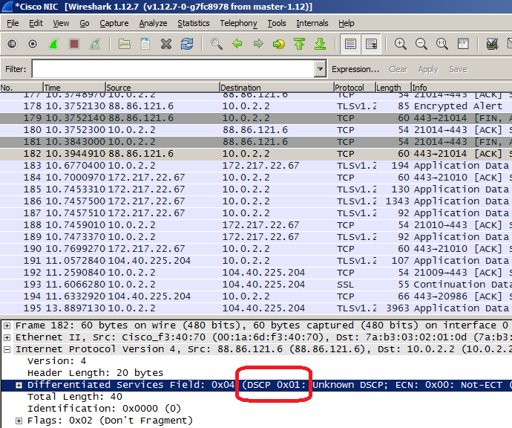

* Prevádzke FTP a SFTP sme nastavili DSCP 2

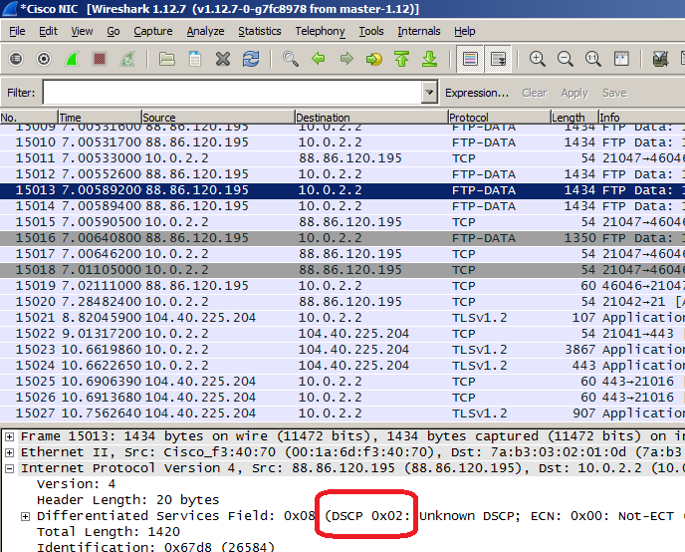

## Úloha 3

Po vygenerovaní FTP, HTTP a HTTPS prevádzky sme pozreli štaistiky NBAR-u

Receiver#show ip nbar protocol-discovery top-n 5

FastEthernet0/0

Last clearing of "show ip nbar protocol-discovery" counters 00:02:20

Input Output

----- ------

Protocol Packet Count Packet Count

Byte Count Byte Count

5min Bit Rate (bps) 5min Bit Rate (bps)

5min Max Bit Rate (bps) 5min Max Bit Rate (bps)

------------------------ ------------------------ ---------------------

ftp 4976 10693

316993 15262548

12000 407000

12000 407000

http 2422 4831

246843 6432969

6000 160000

9000 172000

secure-http 579 852

97425 631434

4000 21000

7000 24000

dns 96 96

7569 12645

0 0

2000 3000

unknown 303 142

18864 8924

1000 0

3000 2000

Total 8377 16615

687694 22348520

23000 588000

33000 608000

Následne sme pozreli defaultné protokoly, ktoré NBAR používa:

Receiver#show ip nbar protocol-pack active detail

Active Protocol Pack:

Name: Standard Protocol Pack

Version: 1.0

Publisher: Cisco Systems Inc.

NBAR Engine Version: 16

State: Active

Modules:

1 base Mv: 4

2 ftp Mv: 4

3 http Mv: 17

Iv: kazaa2 - 11

Iv: irc - 1

4 static Mv: 6

5 secure-http Mv: 4

6 netbios Mv: 1

7 socks Mv: 2

8 nntp Mv: 2

9 tftp Mv: 2

10 exchange Mv: 3

11 vdolive Mv: 1

12 sqlnet Mv: 2

13 netshow Mv: 3

14 sunrpc Mv: 3

15 streamwork Mv: 2

16 citrix Mv: 13

17 fasttrack Mv: 3

18 gnutella Mv: 7

19 kazaa2 Mv: 11

Iv: http - 17

20 dhcp Mv: 1

21 rtsp Mv: 6

22 rtp Mv: 7

23 mgcp Mv: 2

24 skinny Mv: 3

25 h323 Mv: 1

26 sip Mv: 4

27 rtcp Mv: 4

28 edonkey Mv: 6

29 winmx Mv: 4

30 bittorrent Mv: 5

Iv: socks - 2

31 directconnect Mv: 4

32 imap Mv: 1

33 pop3 Mv: 1

34 irc Mv: 1

Iv: http - 17

35 smtp Mv: 1

36 dns Mv: 1

37 skype Mv: 3

38 sap Mv: 1

39 pptp Mv: 1

40 ntp Mv: 1

41 iana Mv: 1

42 custom-protocols Mv: 1